

**Capstone Project Report**

**Report 3 – Software Requirement Specification**

Professor: Nguyễn Thị Thanh Trúc

Class: SE104.M21.PMCL

Student 1: Hồ Minh Tuệ - 20520850

Student 2: Lưu Kim Triều - 20520941

Student 3: Nguyễn Tuấn Kiệt - 20520906

**Table of Contents**

I. Project Report 3

1. Status Report 3

2. Team Involvements 3

3. Issues/Suggestions 3

II. Software Requirement Specification 4

1. Overall Description 4

1.1 Product Overview 4

2. User Requirements 5

2.1 System Actors 5

2.2 Use Cases 5

3. Functional Requirements 6

3.1 System Functional Overview 6

3.2 Signing in 7

3.3 Selling 8

3.4 Manage Staff Account 9

3.5 Manage Warehouse 10

3.6 Report 11

# I. Record of Changes

|  |  |  |  |
| --- | --- | --- | --- |
| Date | A* M, D | In charge | Change Description |
|  |  |  |  |
|  |  |  |  |
|  |  |  |  |
|  |  |  |  |
|  |  |  |  |
|  |  |  |  |
|  |  |  |  |
|  |  |  |  |
|  |  |  |  |
|  |  |  |  |
|  |  |  |  |
|  |  |  |  |
|  |  |  |  |

*A - Added M - Modified D - Deleted

# II. Software Requirement Specification

## 1. Product Overview

The Grocery Store Application is a new software that helps managers manage their grocery store more conveniently and more easily. The context diagram below illustrates the external entities and system interfaces for release 1.0. The system is expected to evolve over several releases.

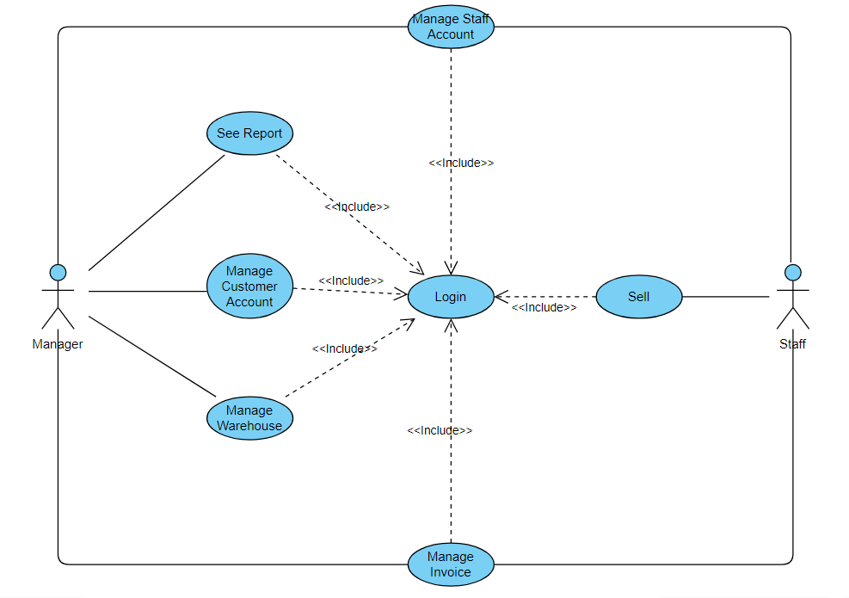

## 2. User Requirements

### 2.1 Actors

|  |  |  |
| --- | --- | --- |
| **#** | **Actor** | **Description** |
| 1 | Manager | Manager is play a role as the boss and have the right to manage staff accounts, customer accounts, bills, warehouse and see a report. |
| 2 | Staff | Staff is an employee of the store and can issue an invoice when they sell product, or they can create account for customer and see a list of bills. |

### 2.2 Use Cases

#### 2.2.1 Diagram(s)

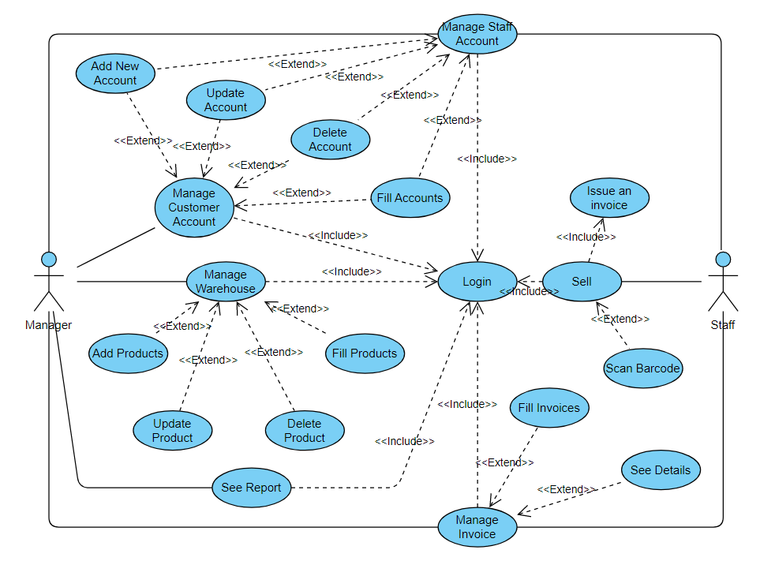

#### 2.2.2 Descriptions

*This part describes the use cases, you can follow the table form as below]*

|  |  |  |  |
| --- | --- | --- | --- |
| **ID** | **Use Case** | **Actors** | **Use Case Description** |
| 01 | Manage Staff Account | Manager | Include add new, update, delete and fill staff accounts |
| 02 | Manage Customer Account | Manager, Staff | Include add new, update, delete and fill customer accounts |
| 03 | Manage Warehouse | Manager | Include add new, update, delete and fill products |
| 04 | See Report | Manager | Display the number of products sold and revenue monthly, yearly |
| 05 | Manage Invoice | Manager, Staff | View invoice details and filter invoices |
| 06 | Sell Products | Staff | Make payments and issue invoices |

## 3. Functional Requirements

### 3.1 System Functional Overview

*[Provide functionality overview of software system: screen flow, screen descriptions, system user roles, screen authorization, non-screen functions, ERD]*

#### 3.1.1 Screens Flow

#### 

#### 3.1.2 Screen Descriptions

*[Provide the descriptions for the screens in the Screens Flow above]*

|  |  |  |  |
| --- | --- | --- | --- |
| **#** | **Feature** | **Screen** | **Description** |
| 1 | Manage Staff | Staff | Create, update, delete, fill accounts. View staffs list. |
| 2 | Manage Customer | Customer | Create, update, delete, fill accounts. View customer list. |
| 3 | Manage Warehouse | Warehouse | Create, update, delete, fill products. View products list. |
| 4 | Manage Invoice | Invoice | Show invoice details and filter invoices. View invoices list. |
| 5 | See Report | Report | Display the number of products sold and revenue monthly. |
| 6 | Sell Products | Sale | Show purchase details, payments and issue invoices. |

### 3.2 Signing in

#### 3.2.1 Description

Any User has an account can have access to the system.

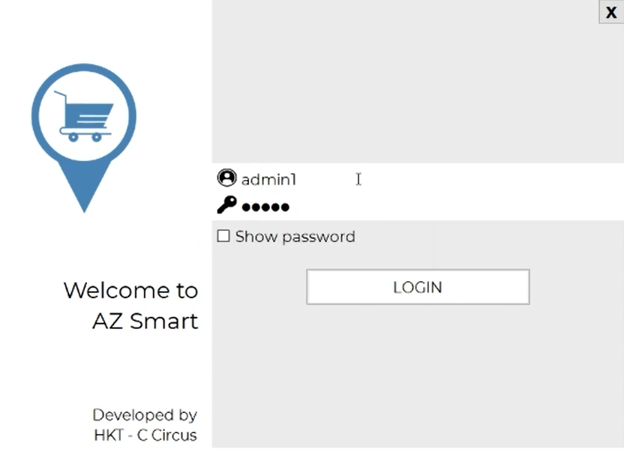

***3.2.2 Requirements***

*Request for logging in*

*Introduction*

•The application asks for User’s username and password and asks for its verification via the Database.

*Inputs*

•User’s username

•User’s password

*Processing*

•The application checks for the combination from the data in the Database.

*Outputs*

If the username and password match in the Database, app gives confirmation for success in logging in and redirects User to Home Page. Otherwise, app gives unsuccessful confirmation.

### 

### 3.3 Selling

#### 3.3.1 Description

Any Customer may make payments with any items they have put in their troller. A Customer may change the amount, change a specific item or cancel buying at the Cashier.

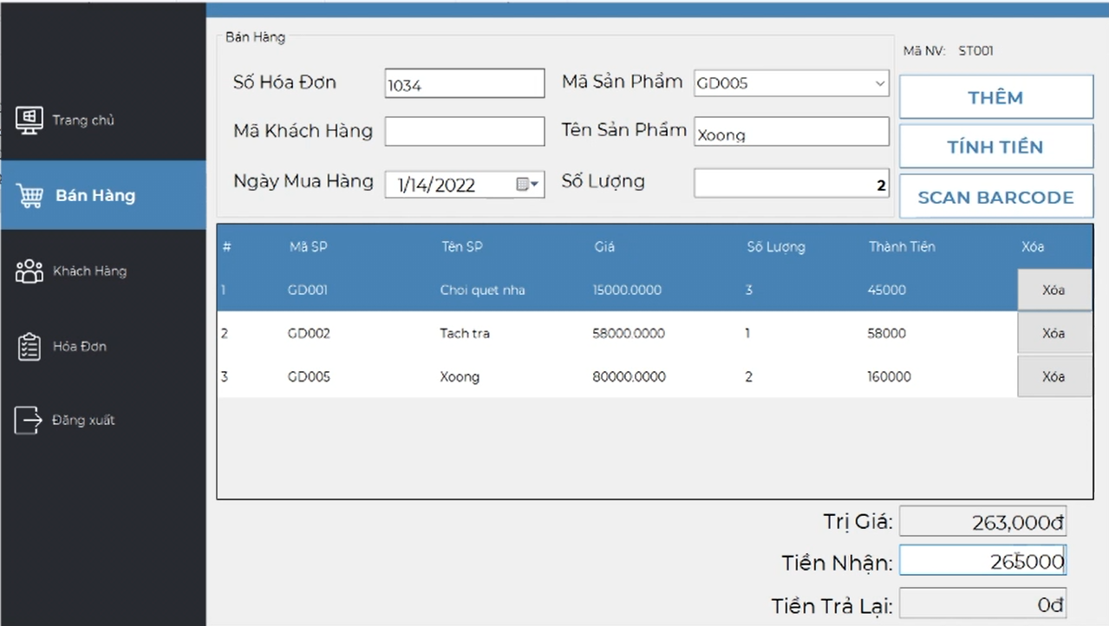

***3.3.1 Requirements***

*Introduction*

•A sale transaction both authorizes and settles the requested amount against the payment method indicated. Through authorizing, the Transaction request confirms that the payment method exists and that funds are available at the time of Authorization to cover the transaction amount.

*Inputs*

•Products' IDs.

*Processing*

•The app queries the database for the product information and calculates the total amount payable after inclusion of taxes and discounts.

•A bill is created in a printable format.

*Outputs*

•A formatted bill is printed for the customer.

### 3.4 Manage Staff Account

#### 3.4.1 Description

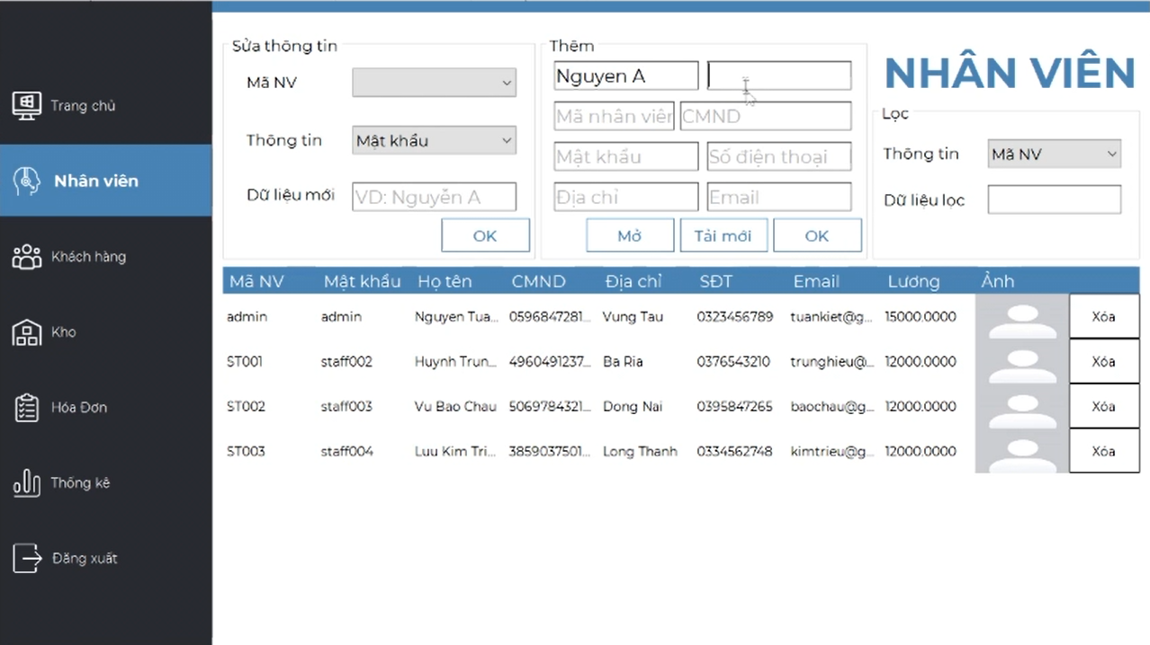

***3.4.2 Requirements***

*Introduction*

•A sale transaction both authorizes and settles the requested amount against the payment method indicated. Through authorizing, the Transaction request confirms that the payment method exists and that funds are available at the time of Authorization to cover the transaction amount.

*Inputs*

•Products' IDs.

*Processing*

•The app queries the database for the product information and calculates the total amount payable after inclusion of taxes and discounts.

•A bill is created in a printable format.

*Outputs*

•A formatted bill is printed for the customer.

### 3.5 Manage Warehouse

***3.5.1 Description***

Manager is authorized to view and modify different commodities in the inventory of the Store. He can change the price, add/delete new goods and import goods for sale.

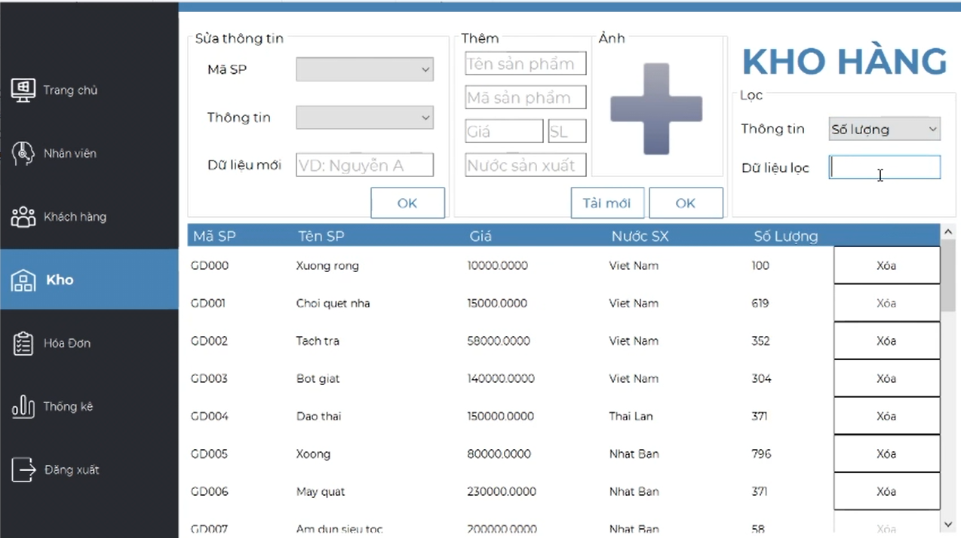

***3.5.2 Requirements***

*Updating the inventory*

*Introduction*

•Staff adds new items to the inventory which have newly arrived*.*

*Inputs*

•The product ID and quantity of the product imported.

*Processing*

•The app looks into the database, if the product ID already exists in the inventory database, the quantity is updated otherwise new product information has to be added to the database.

*Outputs*

•A message is displayed confirming the update regarding the product ID and amount.

*Delete a product*

*Introduction*

•Staff deletes one item from the inventory*.*

*Inputs*

•The product ID.

*Processing*

•The app looks into the database, if the product ID match with the item, it will be deleted.

*Outputs*

•A message is displayed confirming the product has been deleted and reload a product list.

### 3.6 Report

***3.6.1 Description***

The application displays the number of products sold and revenue monthly.

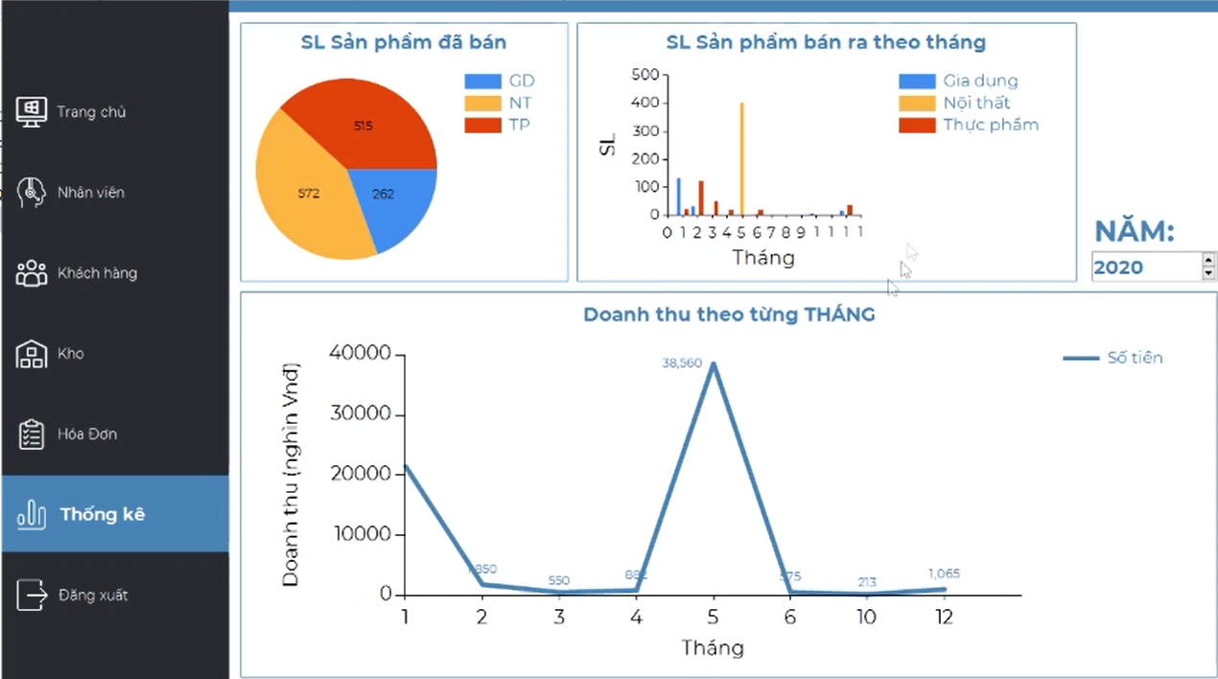

***3.6.2 Requirements***

*Introduction*

•The app will diplay the number of products sold and revenue based on database by a graph.

*Inputs*

•The ID’s product and number of products via invoice.

*Processing*

•The application will calculate the number of products sold.

*Outputs*

•A graph indicates the number of products sold and revenue monthly.

## 4. Non-Functional Requirements

### 4.1 External Interfaces

*[This section provides information to ensure that the system will communicate properly with users and with external hardware or software/system elements.]*

### 4.2 Quality Attributes

*[List all the required system characteristics (quality attributes) specification. Some of the possible attributes are provided with the guide/descriptions are mentioned here]*

#### 4.2.1 Usability

*[This section includes all those requirements that affect usability. For example, specify the required training time for a normal users and a power user to become productive at particular operations specify measurable task times for typical tasks or base the new system’s usability requirements on other systems that the users know and like specify requirement to conform to common usability standards, such as IBM’s CUA standards Microsoft’s GUI standards]*

#### 4.2.2 Reliability

*[Requirements for reliability of the system should be specified here. Some suggestions follow:*

*Availability—specify the percentage of time available ( xx.xx%), hours of use, maintenance access, degraded mode operations, and so on.*

*Mean Time Between Failures (MTBF) — this is usually specified in hours, but it could also be specified in terms of days, months or years.*

*Mean Time To Repair (MTTR)—how long is the system allowed to be out of operation after it has failed?*

*Accuracy—specifies precision (resolution) and accuracy (by some known standard) that is required in the system’s output.*

*Maximum Bugs or Defect Rate—usually expressed in terms of bugs per thousand lines of code (bugs/KLOC) or bugs per function-point( bugs/function-point).*

*Bugs or Defect Rate—categorized in terms of minor, significant, and critical bugs: the requirement(s) must define what is meant by a “critical” bug; for example, complete loss of data or a complete inability to use certain parts of the system’s functionality.]*

#### 4.2.3 Performance

*[The system’s performance characteristics are outlined in this section. Include specific response times. Where applicable, reference related Use Cases by name.*

*Response time for a transaction (average, maximum)*

*Throughput, for example, transactions per second*

*Capacity, for example, the number of customers or transactions the system can accommodate*

*Resource utilization, such as memory, disk, communications, and so forth.]*

#### 4.2.4 …

## 5. Requirement Appendix

*[Provide business rules, common requirements, or other extra requirements information here]*

### 5.1 Business Rules

*[Provide common business rules that you must follow. The information can be provided in the table format as the sample below]*

|  |  |
| --- | --- |
| ID | Rule Definition |
| BR-01 | Delivery time windows are 15 minutes, beginning on each quarter hour. |
| BR-02 | Deliveries must be completed between 10:00 A.M. and 2:00 P.M. local time, inclusive. |
| BR-03 | All meals in a single order must be delivered to the same location. |
| BR-04 | All meals in a single order must be paid for by using the same payment method. |
| BR-11 | If an order is to be delivered, the patron must pay by payroll deduction. |
| BR-12 | Order price is calculated as the sum of each food item price times the quantity of that food item ordered, plus applicable sales tax, plus a delivery charge if a meal is delivered outside the free delivery zone. |
| BR-24 | Only cafeteria employees who are designated as Menu Managers by the Cafeteria Manager can create, modify, or delete cafeteria menus. |
| BR-33 | Network transmissions that involve financial information or personally identifiable information require 256-bit encryption. |
| BR-86 | Only regular employees can register for payroll deduction for any company purchase. |
| BR-88 | An employee can register for payroll deduction payment of cafeteria meals if no more than 40 percent of his gross pay is currently being deducted for other reasons. |

### 5.2 Common Requirements

*[Fill all the common requirements here..]*

### 5.3 Application Messages List

|  |  |  |  |  |
| --- | --- | --- | --- | --- |
| **#** | **Message code** | **Message Type** | **Context** | **Content** |
| 1 | MSG01 | In line | There is not any search result | *No search results.* |
| 2 | MSG02 | In red, under the text box | Input-required fields are empty | *The * field is required.* |
| 3 | MSG03 | Toast message | Updating asset(s) information successfully | *Update asset(s) successfully.* |
| 4 | MSG04 | Toast message | Adding new asset successfully | *Add asset successfully.* |
| 5 | MSG05 | Toast message | Confirming email of asset hand-over is sent successfully | *A confirmation email has been sent to {email_address}.* |
| 6 | MSG06 | Toast message | Resetting asset information successfully | *Return asset(s) successfully.* |
| 7 | MSG07 | Toast message | Deleting asset information successfully | *Delete asset(s) successfully.* |
| 8 | MSG08 | In red, under the text box | Input value length > max length | *Exceed max length of {max_length}.* |
| 9 | MSG09 | In line | Username or password is not correct when clicking sign-in | *Incorrrect user name or password. Please check again.* |

### 5.4 Other Requirements…